Thinking process, tasks, architecture and others

Expressions
General definitions
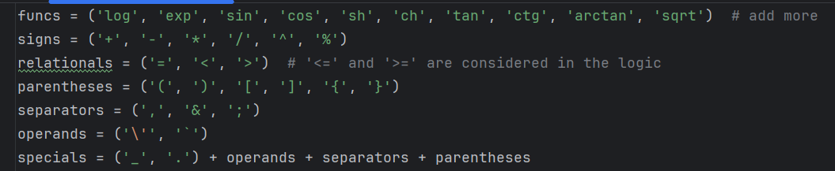
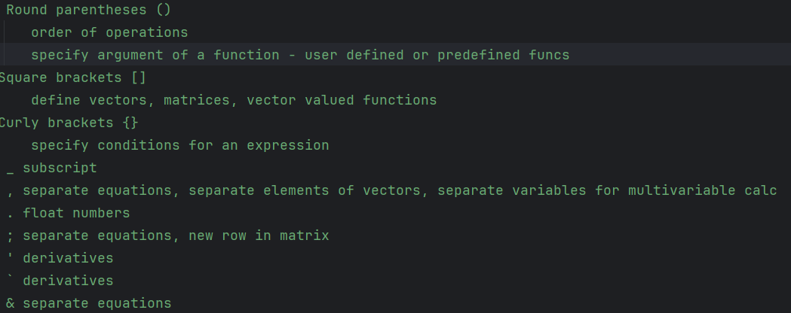
Future ideas – keywords ( and or real complex integer positive …)

Function 1
analyses the input string and validates it based on a series of conditions:
- zero length string
- expression ends with a sign
- 2 consecutive signs (except +-)
- 2 forbidden consecutive relational operators
- non-supported characters
- alpha groups are interrupted (e.g. 'x23y') (strings like 'x1' will be allowed as a subscript typo)
- limit exceeded for consecutive letters not in funcs
- any sort of bad placement of characters ('_', ',', '.', ';', '\'', '`', '&') or parentheses
- functions have invalid content (first testing)

Function 2
If function 1 ok, process the string, normalize it and store it in memory by standard rules

